Animal or Plant Cell Model

Your task is to create either a plant or animal cell model from the materials you have at home. You will need to label the following organelles on your cell model and you will need to be able to answer some questions about what these organelles do.

Cell membrane Cytoplasm Mitochondria
Lysosome Ribosome Nucleus
Golgi apparatus Smooth ER Rough ER
Nuclear membrane Vacuole Chloroplast
Golgi body Cell wall

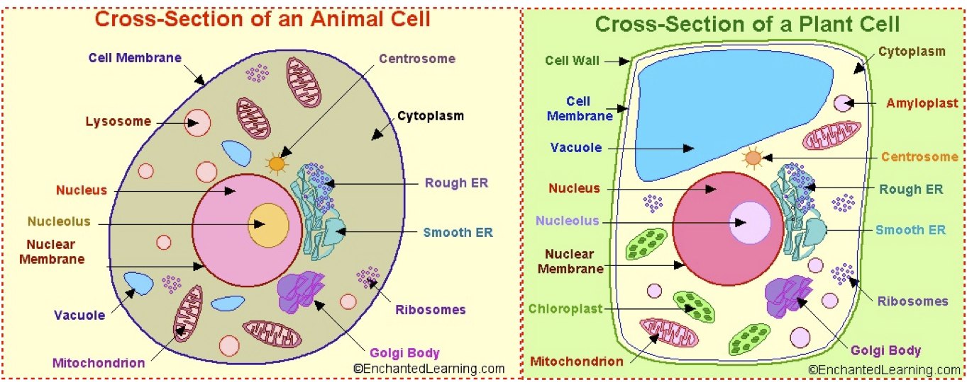
DUE DATE: ______________________
NOTES:

Animal or Plant Cell Model

Your task is to create either a plant or animal cell model from the materials you have at home. You will need to label the following organelles on your cell model and you will need to be able to answer some questions about what these organelles do.

Cell membrane Cytoplasm Mitochondria
Lysosome Ribosome Nucleus
Golgi apparatus Smooth ER Rough ER
Nuclear membrane Vacuole Chloroplast
Golgi body Cell wall

DUE DATE: ______________________
NOTES:

